Official league roster - soccer
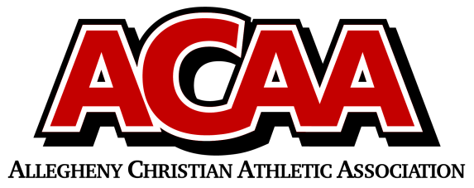
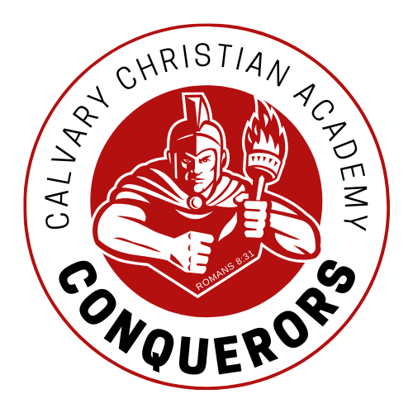
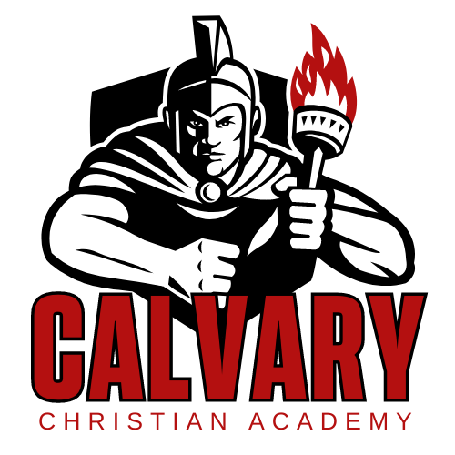

School Name: Calvary Christian Acad.
Team Colors: red/gold/white
Overall Wins ___ Losses ____ Ties ___
ACAA Wins ___ Losses ____ Ties ___ OPPONENT: __________________________
Date: _________
Number | Name | Year | Position | Height | Homeschool
14 | Emily Suttles* | Sr | forward
15 | Kya Kuhstos* | Sr | forward
18, 33 | Bethany Lane | Jr | gk
28 | Macayla Mills | Jr | defense
5 | Katrina Donnelly | Jr | midfield |  | x
11 | Bethany Suttles | Soph | defense
17 | Eva Penning | Soph | defense
7 | Andrea Schroeder | Soph | midfield
25 | Maggie Taylor | Soph | midfield
10 | Sarah Hetrick | Fresh | forward
12 | Leah Slusher | Fresh | midfield |  | x
13 | Ella Willis | Fresh | defense
9 | Nicole Ranck | 8 | midfield
 | Nora Cahill | 7 | midfield |  | x
27 | Olivia Mills | 7 | defense
20 | Amelia Feaster | 7 | midfield
21 | Ava Fox | 7 | defense
MGR | Lael Corbin | 9 | mgr
 | *Denotes team captain

Head Coach: Kristen haertlein
Asst. coach: Joy martin
Asst. coach:

Official ACAA League Team Roster. to be submitted to the scorer’s table before each game.

